**Database Systems Project – 1 From: Prawal Sharma UTA ID: 1001104720**

**Task – 1**

1. **List of Entities:** 
   1. Postcard
   2. ThematicCategories
   3. TimePeriod
   4. PostcardCategories
2. **For each attribute:**

|  |  |
| --- | --- |
| **Postcard** | |
| p_Id | Int(5) |
| t_id | Int(5) |
| title | Varchar(30) |
| description | Varchar(255) |
| color | Varchar(15) |
| condition | Varchar(25) |
| date | Date |
| price | Int(10) |
|  | |
| **TimePeriod** |  |
| t_id | Int(5) |
| time_era | Varchar(25) |
|  | |
| **ThematicCategories** |  |
| cat_Id | Int(5) |
| category | Varchar(50) |
|  | |
| **PostcardCategories** |  |
| p_id | Int(5) |
| cat_id | Int(5) |

**Task – 2**

1. 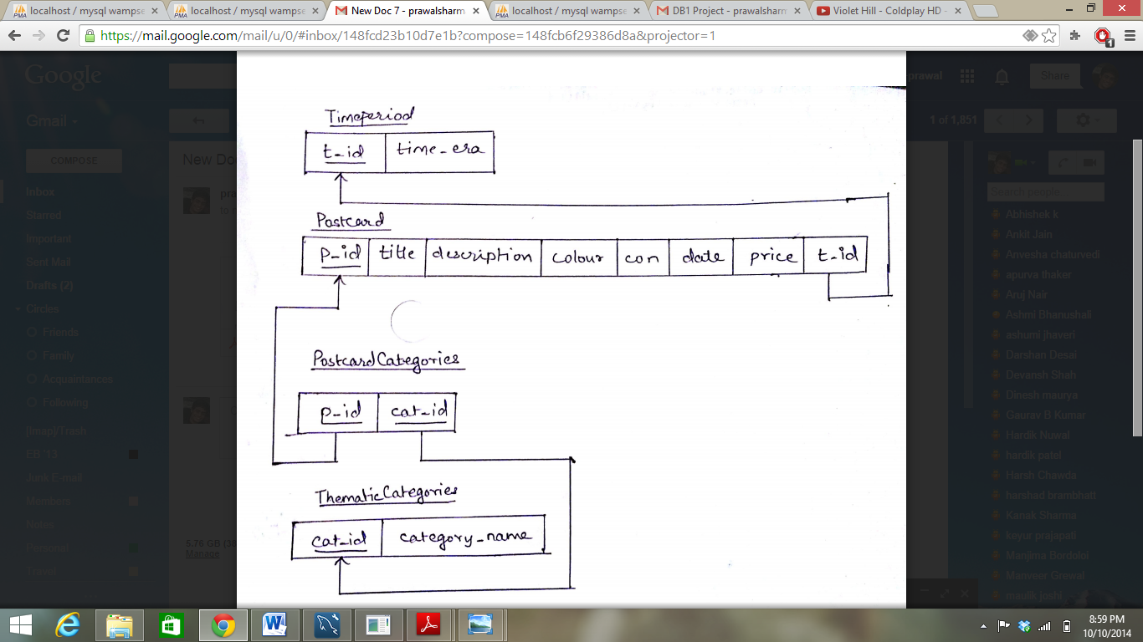**Database Schema:**
   1. About relationships. There are a total of 3 relations
      1. The relation between **Postcard** and **PostcardCategories** defines which category does a postcard belongs to.
      2. The relationship between **PostcardCategories** and **ThematicCategories** defines each Thematic Category can be related to many tuples of the PostcardCategories. Explicitly, the relationship i. & ii. satisfies the condition of one postcard being associated with many categories, and one category to be associated with many postcards.
      3. The third relation between **Postcard** and **TimePeriod** states which time era does a single postcard belongs to.
   2. Cardinality of relationships:
      1. **Postcard** and **PostcardCategories** is a **many to one** relationship
      2. **PostcardCategories** and **ThematicCategories** has a **one to many** relationship
      3. **Postcard** and **TimePeriod** has a **one to one** relationship
2. **Constraints:** 
   1. **Primary Key** of Postcard, TimePeriod and ThematicCategories cannot be NULL. This is **Entity Constraints.**
   2. **Foreign Key**: Time_Id in Postcard is a Primary Key: Time_Id in TimePeriod. This is **Referential Integrity Constraints.**
   3. **Foreign Key**: Postcard_Id, **Foreign Key:** Cat_Id in PostcardCategories is a **Primary Key:** Postcard_Id, **Primary Key:** Cat_Id in Postcard and ThematicCategory respectively. This is a **Referential Integrity Constraint**.
   4. There is a Key that uniquely identifies the entity in the schema. This is a **Key Constraint**.

**Task – 3**

1. **SQL Code to implement Schema:**

* CREATE DATABASE postcard;
* USE postcard;
* CREATE TABLE TimePeriod(t_id int(5) NOT NULL, time_era varchar(25), PRIMARY KEY(t_id));
* CREATE TABLE ThematicCategories(cat_id int(5) NOT NULL, category_name varchar(25), PRIMARY KEY (cat_id));
* CREATE TABLE postcard(p_id int(5) NOT NULL, t_id int(5), title varchar(30), description varchar(255), colour varchar(15),con varchar(25), p_date DATE, price double, PRIMARY KEY(p_id), FOREIGN KEY (t_id) REFERENCES timeperiod (t_id) );
* CREATE TABLE postcardcategories(p_id int(5), cat_id int(5), PRIMARY KEY(p_id,cat_id), FOREIGN KEY (p_id) REFERENCES postcard(p_id), FOREIGN KEY (cat_id) REFERENCES thematiccategories(cat_id));

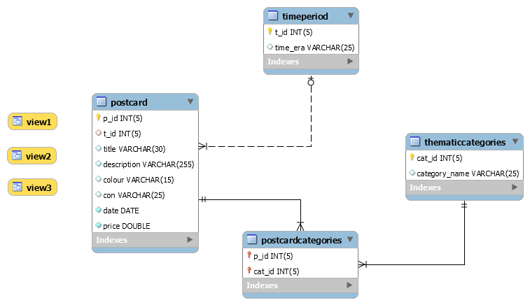

1. **Populate Table**

Time Period:

* INSERT INTO timeperiod(t_id,time_era) VALUES (2,'silverera'), (3,'modernera');

Thematic Categories:

* INSERT INTO thematiccategories(cat_id,category_name) VALUES (1,'nature'),(2,'buildings'),(3,'people');

Postcard:

* INSERT INTO postcard (`p_id`, `t_id`, `title`, `description`, `colour`, `con`,`date`, `price`) VALUES ('1', '1', 'Happy Birthday', 'For Celebrating Birthday', 'b/w', 'mint', '2014-10-05', '21.3'),('2', '3', 'Official Posts', 'Commercial uses of postcards', 'b/w', 'mint', '2011-04-5', '12.33'), ('3', '3', 'Official Posts', 'Commercial uses of postcards', 'b/w', 'acceptable', '2009-9-30', '3.44'), ('4', '2', 'Adventure Sports', 'Cards dedicated towards adventure sports.', 'color', 'very good', '2011-3-3', '14.33'), ('5', '1', 'Adventure Sports', 'Cards dedicated towards adventure sports.', 'color', 'poor', '2008-7-25', '34.5'), ('6', '1', 'Happy Birthday', 'For Celebrating birthday.', 'b/w', 'good', '2013-6-5', '10.25'), ('7', '2', 'Summer', 'Postcards that relate to summer season.', 'color', 'acceptable', '2012-3-9', '6.55'), ('8', '3', 'Get Well Soon', 'Cards to ease people in pain.', 'b/w', 'good', '2007-7-16', '7.66'), ('9', '1', 'European Mail', 'Used at the time of mail in Europe continent.', 'color', 'poor', '2011-9-13', '2.55'), ('10', '1', 'European Mail', 'Used at the time of mail in Europe continent.', 'color', 'acceptable', '2012-3-4', '12.55'), ('11', '1', 'Ancient Mails', 'Postcards used in ancient times as mails', 'b/w', 'poor', '2013-9-13', '133.66'), ('12', '3', 'Gift Postcards', 'Used to greet people with gift.', 'color', 'mint', '2012-2-3', '5.88'), ('13', '2', 'Telegram Postcard', 'Elegant Telegram styled postcard', 'color', 'good', '2014-7-3', '17.35'), ('14', '2', 'Religious Postcards', 'Describes the specific religion', 'b/w', 'good', '2014-10-05', '7.55'), ('15', '2', 'Mauritius', 'Holidays in Mauritius', 'color', 'acceptable', '2011-5-30', '30.22'), ('16', '3', 'Mountains', 'Description about the mountains of Central Asia', 'color', 'good', '2008-3-1', '100'), ('17', '1', 'Architecture', 'About the people and building', 'color', 'good', '2008-3-1', '100');

PostcardCategories:

* INSERT INTO `postcard`.`postcardcategories` (`p_id`, `cat_id`)VALUES ('1', '3'), ('2', '3'), ('3', '3'), ('4', '1'), ('4', '3'), ('5', '1'), ('5', '3'), ('6', '3'), ('7', '1'), ('8', '3'), ('9', '2'), ('9', '3'), ('10', '2'), ('10', '3'), ('11', '2'), ('11', '3'), ('12', '2'), ('12', '3'), ('13', '2'), ('13', '3'), ('14', '1'), ('14', '2'), ('15', '1'), ('15', '3'), ('16', '1'), ('16', '2'), ('17', '1');

1. **Initial State of the Database**

* TimePeriod:

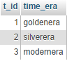

* ThematicCategories:

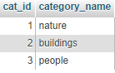

* Postcard:

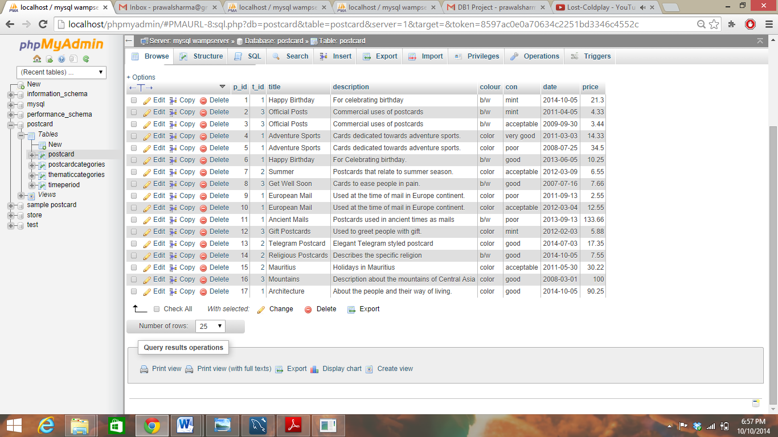

* Postcardcategories:

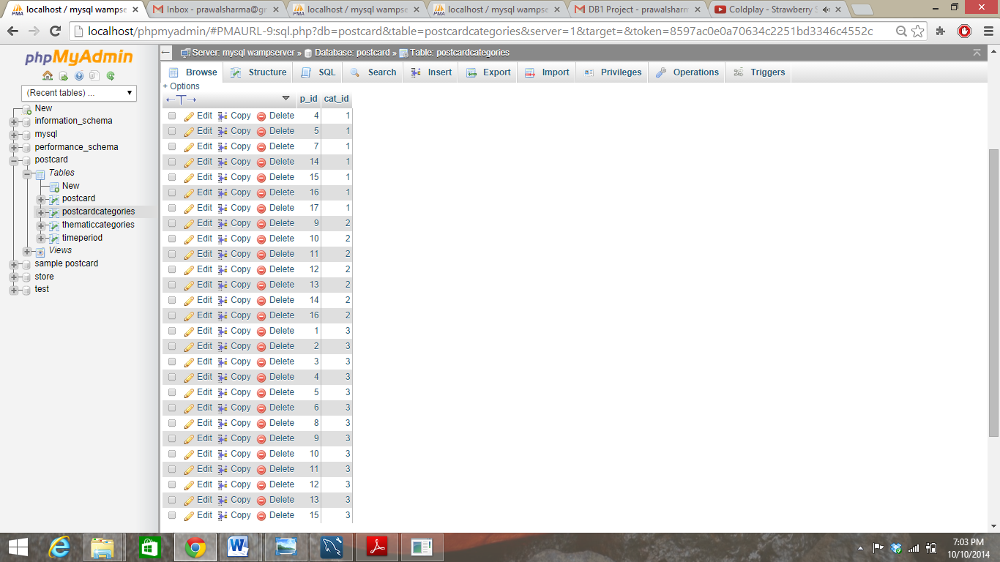

**Task – 4**

1. SELECT title FROM postcard;

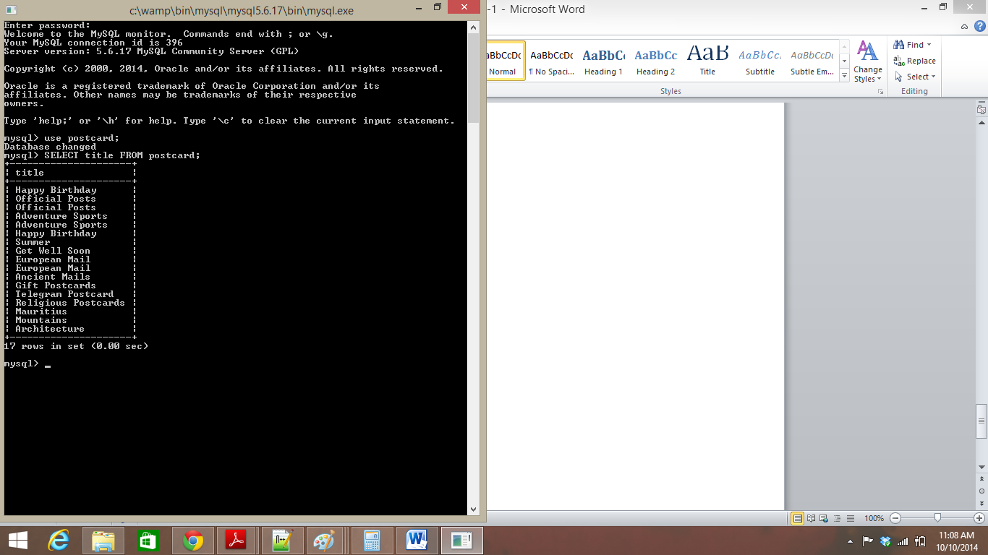

1. SELECT count(*) FROM postcard;

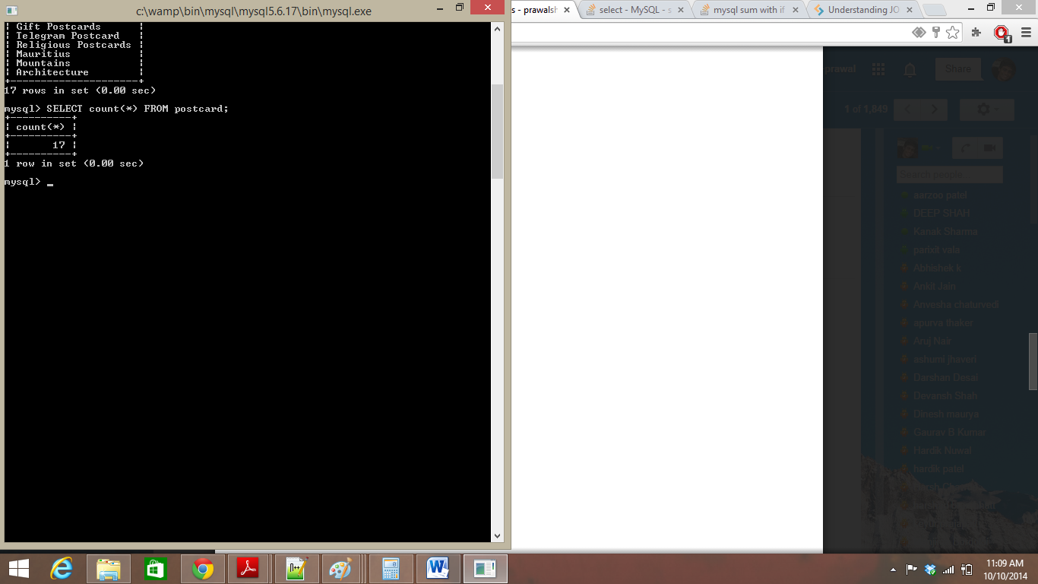

1. SELECT title, count(*) FROM postcard GROUP BY title HAVING count(title)=1;

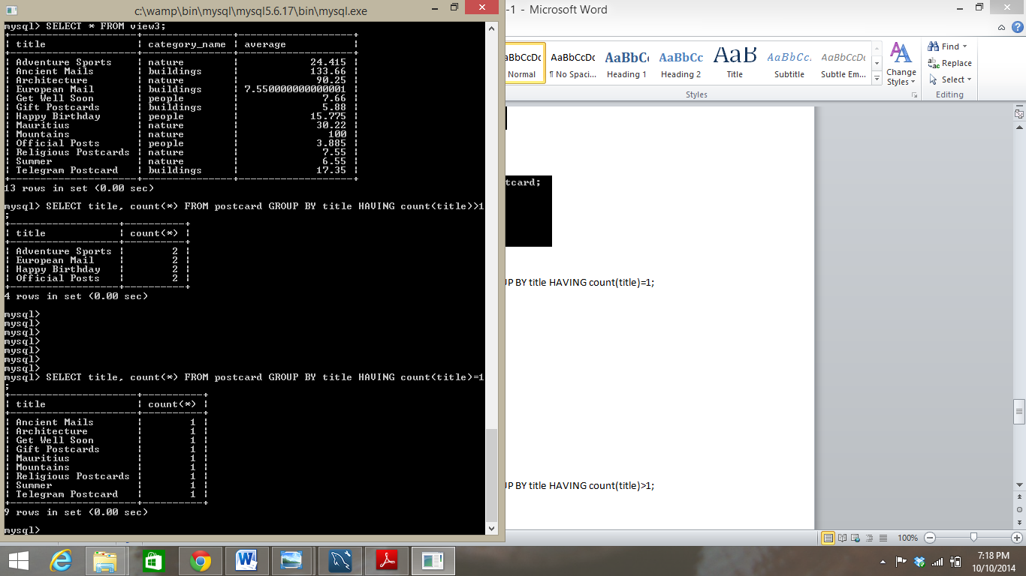

1. SELECT title, count(*) FROM postcard GROUP BY title HAVING count(title)>1;

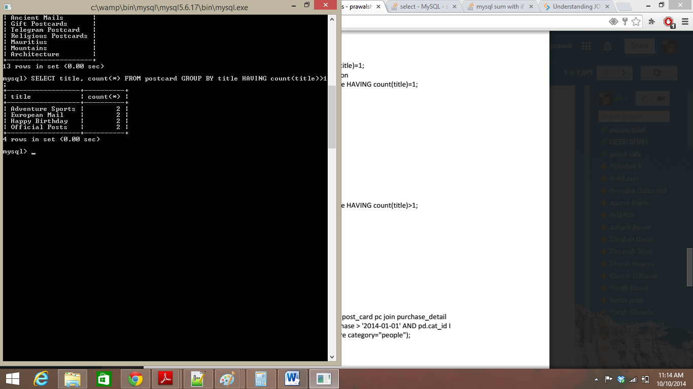

1. SELECT pc.title, pc.date FROM postcard pc JOIN postcardcategories pd ON pc.p_id=pd.p_id WHERE pc.date>’2014-1-1’ AND pd.cat_id IN (SELECT cat_id FROM thematiccategories WHERE category_name=’people’);

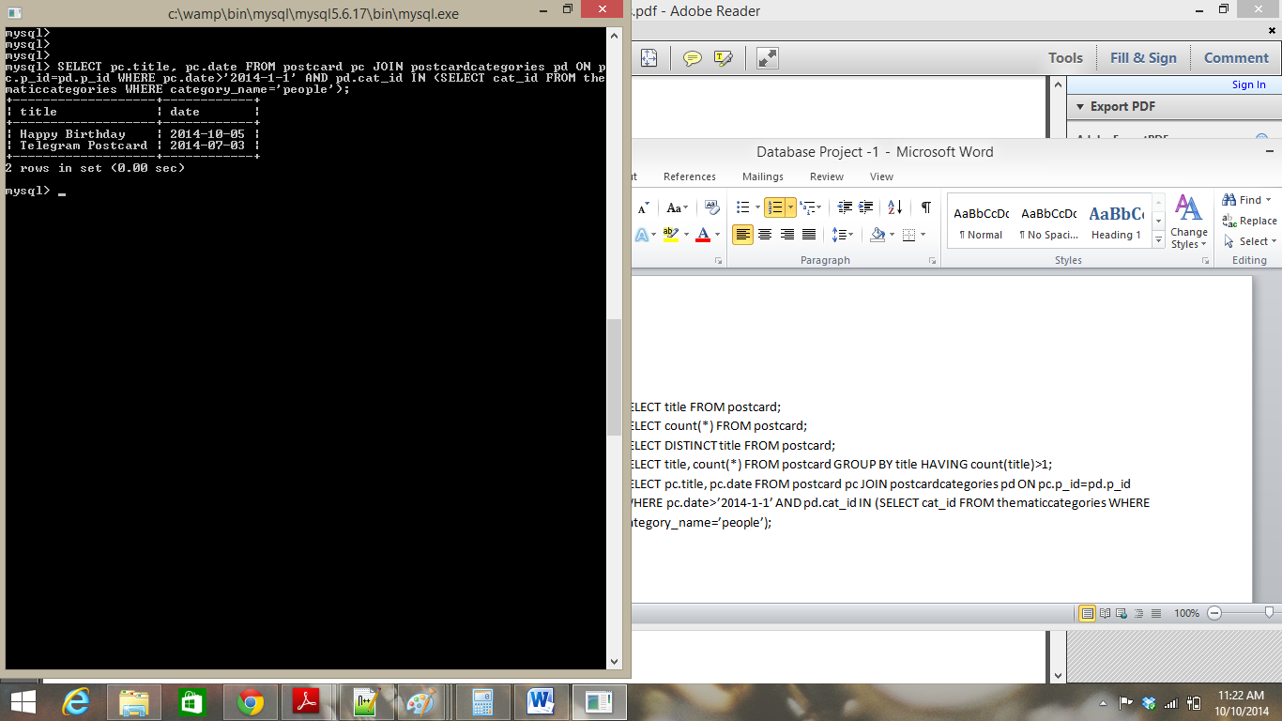

1. SELECT DISTINCT pc.title, pc.p_id FROM postcard pc JOIN timeperiod t ON pc.t_id=t.t_id JOIN postcardcategories pd ON pc.p_id = pd.p_id WHERE pd.cat_id IN (SELECT cat_id FROM thematiccategories WHERE category_name='buildings' OR category_name = 'people') AND t.t_id IN (SELECT t_id FROM timeperiod WHERE time_era="goldenera");

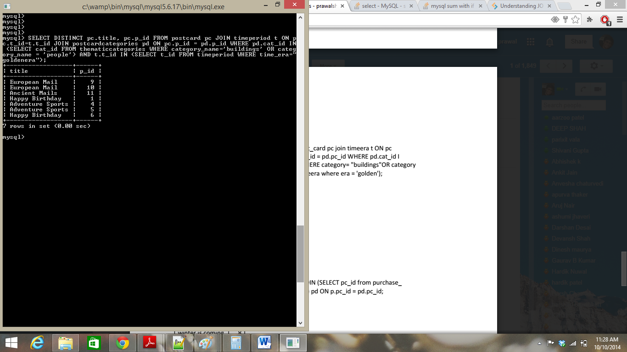

1. SELECT p.title, p.p_id FROM postcard p JOIN (SELECT p_id FROM postcardcategories GROUP BY p_id HAVING count(p_id)>1) pd ON p.p_id=pd.p_id;

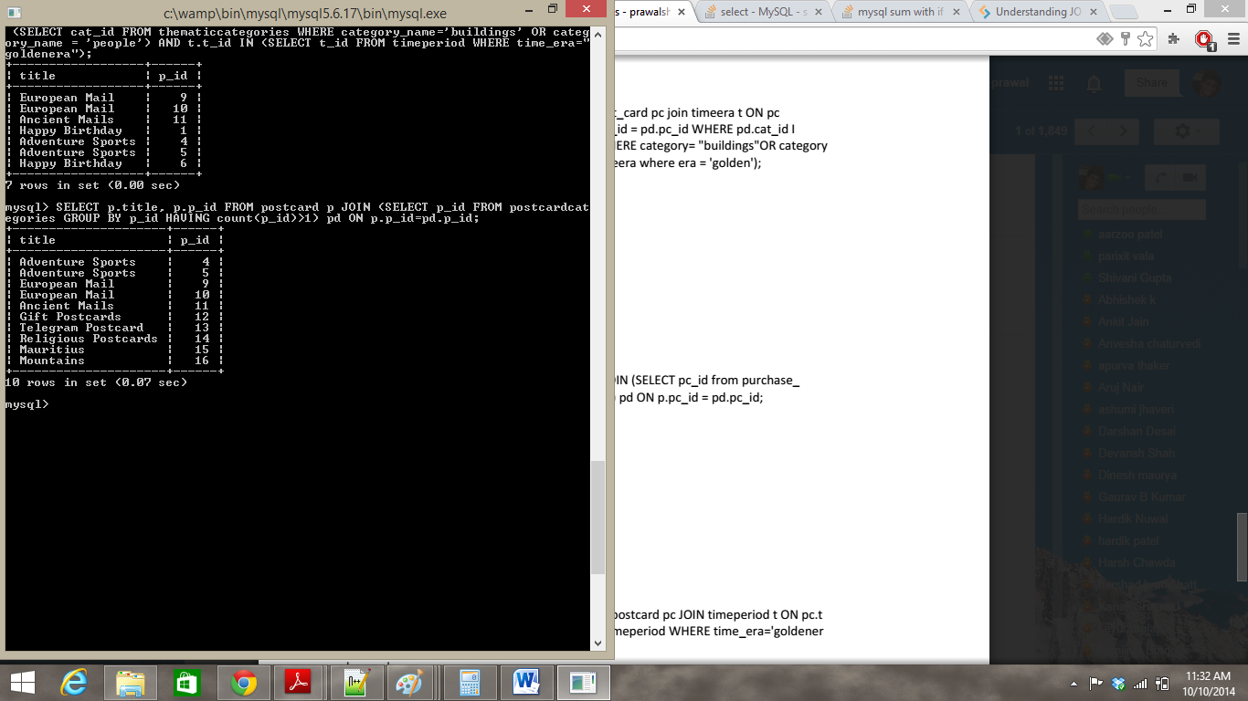

1. SELECT sum(pc.price) AS amount FROM postcard pc JOIN timeperiod t ON pc.t_id=t.t_id WHERE t.t_id IN (SELECT t_id FROM timeperiod WHERE time_era = "silverera");

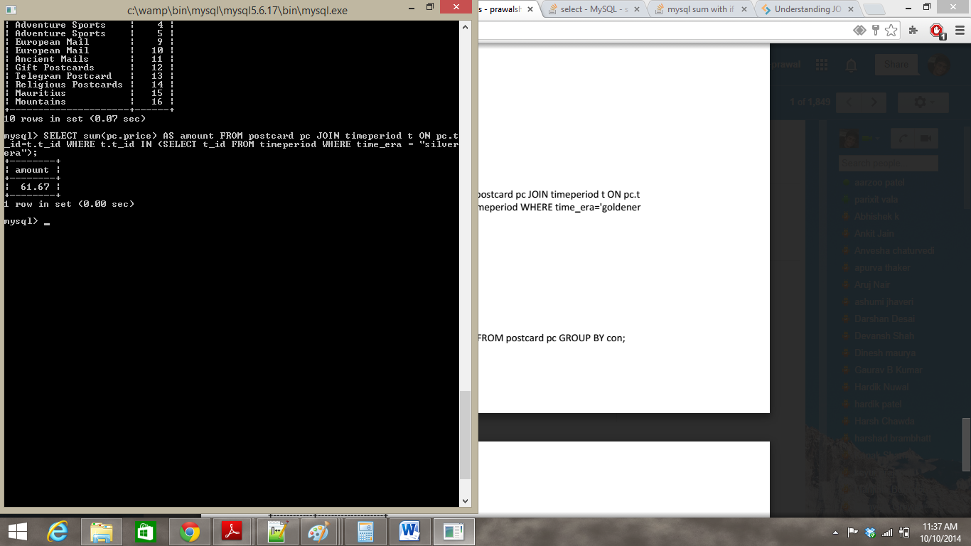

1. SELECT pc.con, avg(pc.price) AS average FROM postcard pc GROUP BY con;

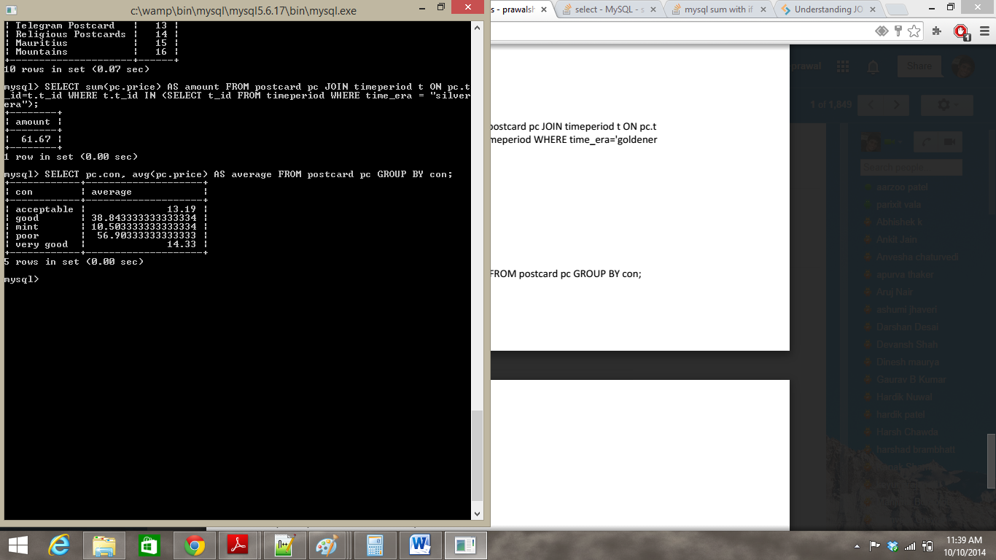

1. SELECT max(price) FROM postcard WHERE con!='poor';

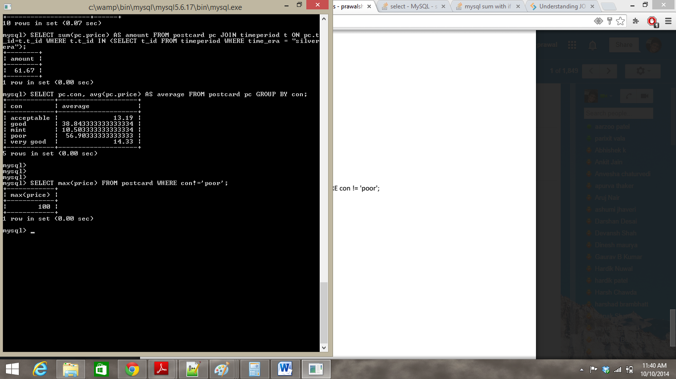

**Task – 5**

1. CREATE VIEW view1 AS SELECT title,con,price FROM postcard;

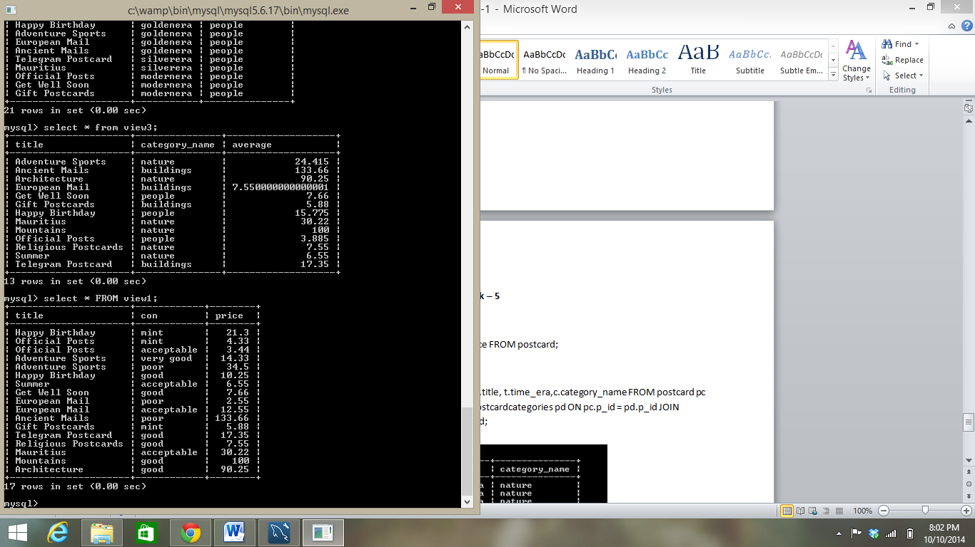

1. CREATE VIEW view2 AS SELECT DISTINCT pc.title, t.time_era,c.category_name FROM postcard pc JOIN timeperiod t ON pc.t_id=t.t_id JOIN postcardcategories pd ON pc.p_id = pd.p_id JOIN thematiccategories c ON pd.cat_id = c.cat_id;

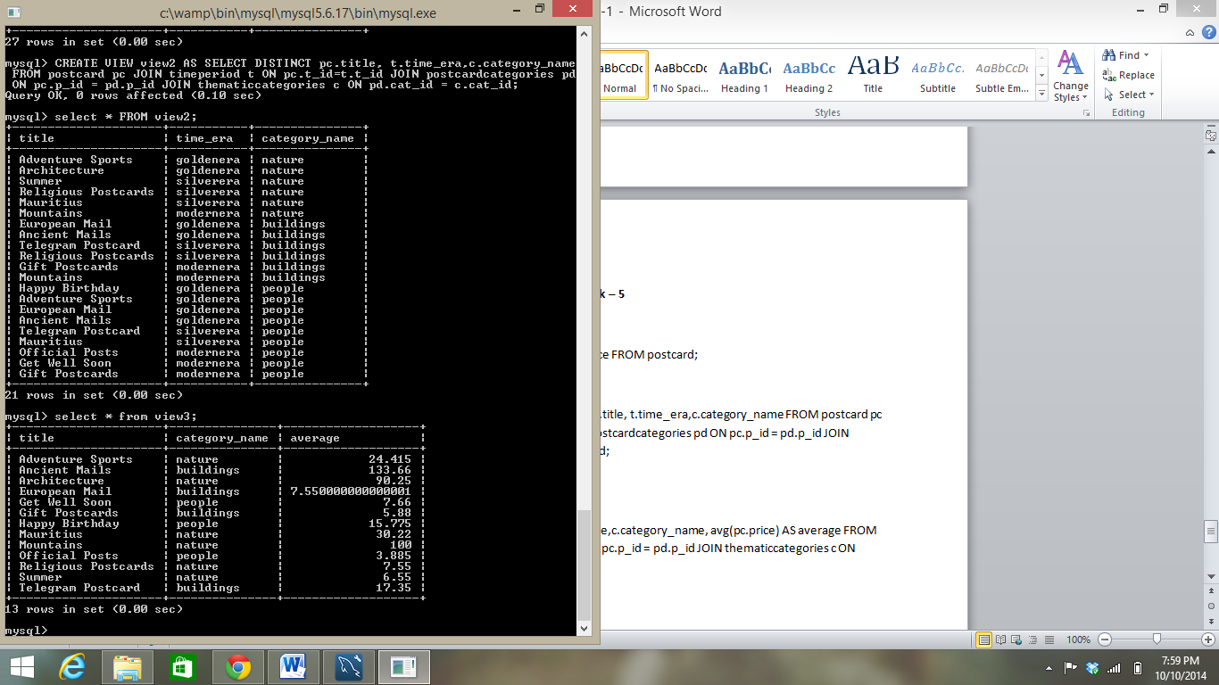

1. CREATE VIEW view3 AS SELECT c.category_name, avg(p.price) FROM postcard p JOIN postcardcategories pd ON pd.p_id = p.p_id JOIN thematiccategories c ON c.cat_id = pd.cat_id GROUP BY c.category_name;

